DBT assignment -11
Que 1) write a query that uses a subquery to obtain all orders from customers named cisneros . Assume you do not know his customer number (cnum)

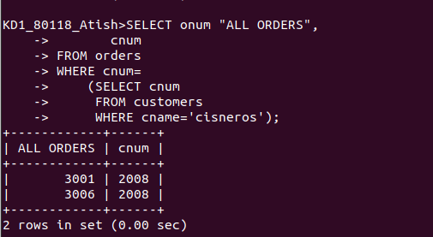
2) Write a query that produces the names and ratings of all customers who have
above-average orders.

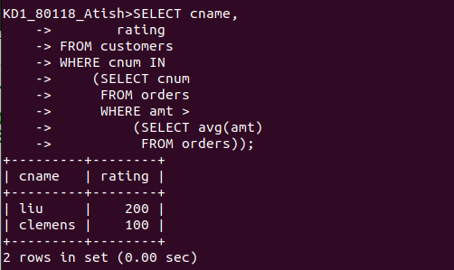

3)) Write a query that selects the total amount in orders for each salesperson for
whom this total is greater than the amount of the largest order in the table.
